HW4 report

The request of this homework is to write a simple to recognize the vowel “e” in the word “Rex”. The idea of this assignment is to combine what you have learned from the previous assignments. While analyzing the formant and energy of the vocal audio, determine the position of the characteristic peak of the vowel to be detected, and then compare the range.

The first is the recording of the walking vocals, which is divided into two groups of ‘Rex’ and ‘Roox’ and stored in a folder. Then enter the main program, import the audio that needs to be processed, and use the matlab package function filter to process the audio. Here we are using STFT processing. Next is the search for formants on the processed signal. Since the parameters used to detect vowel formants are only given two, our processed signal also extracts only the first and second formants. After the size of the positions of the two resonance peaks is extracted, it is used to compare with the given range of "e" to determine whether it is "Rex". The following is the detect result:

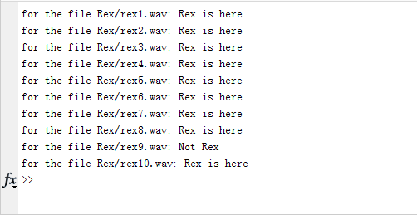

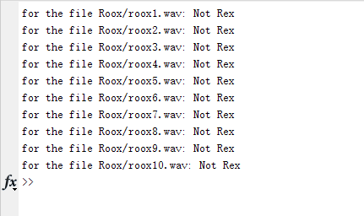

Following the homework request, the first group is “Rex‘ and the second group is “Roox”. If we want to detect vowels in words very accurately, we still need to use machine learning. This is just a simple code, so we adjust the detection range to be wider, floating up and down 300. But it has no effect on the detection of vowels that are large different from vowel "e" and "oo". We can see the results, the detection rate is basically all right.